**Ex. No.**

**:**

**11.1**

**Date: 01.06.2024**

**Register No.: 231401056**

**Name: LAKHSHUYAA SHRI B**

**WEEK 11:**

**1.**

**Write a Python program that asks the user for their age and prints a message based on the age.**

**Ensure that the program handles cases where the input is not a valid integer.**

**Input Format: A single line input representing the user's age.**

**Output Format: Print a message based on the age or an error if the input is invalid.**

**For example:**

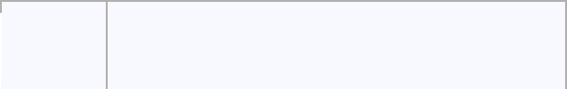

 **Input** **Result**

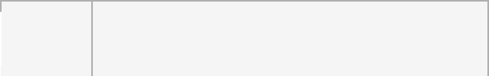

 **twenty Error: Please enter a valid age.**



 **25** **You are 25 years old.**

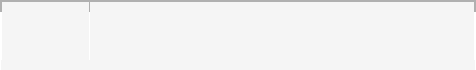

 **-1**  **Error: Please enter a valid age.** 



**try:**

**a=input()**

**if(len(a)==0):**

**print("Error: Please enter a valid age.")**

**elif a.isnumeric():**

**print("You are",a,"years old.")**

**else:**

**print("Error: Please enter a valid age.")**

**except:**

**print("Error: Please enter a valid age.")**



|  |  |
| --- | --- |
| **Department of Computer Science and Engineering | Rajalakshmi Engineering College** | **.** |
|  |  |



**OUTPUT:**



 **Input**  **Expected**



**twent Error: Please enter a valid**

* **age.**



 **25**  **You are 25 years old.**



**-1** **Error: Please enter a valid age.**



 **150**  **You are 150 years old.**



**Error: Please enter a valid age.**

**Passed all tests!**

 **Got**

**Error: Please enter a valid age.**

 **You are 25 years old.**

**Error: Please enter a valid age.**

 **You are 150 years old.**

**Error: Please enter a valid age.**



**Correct**



**2.**

**Problem Description:**

**Write a Python program that asks the user for their age and prints a message based on the age.**

**Ensure that the program handles cases where the input is not a valid integer.**

**Input Format:**

**A single line input representing the user's age.**

**Output Format:**

**Print a message based on the age or an error if the input is invalid.**

**For example:**

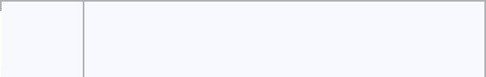

 **Input** **Result**



 **25** **You are 25 years old.**



 **rec** **Error: Please enter a valid age.**



 **-5**  **Error: Please enter a valid age.** 



**try:**

**a=input()**

**if(len(a)==0):**



|  |  |
| --- | --- |
| **Department of Computer Science and Engineering | Rajalakshmi Engineering College** | **.** |
|  |  |



**print("Error: Please enter a valid age.")**

**elif a.isnumeric():**

**print("You are",a,"years old.")**

**else:**

**print("Error: Please enter a valid age.")**

**except:**

**print("Error: Please enter a valid age.")**

**OUTPUT:**

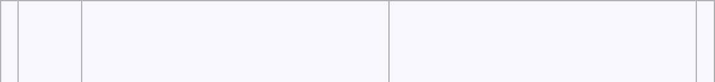

|  |  |  |  |
| --- | --- | --- | --- |
| **Inpu** | **Expected** | **Got** |  |
| **t** |  |
|  |  |  |



 **25**  **You are 25 years old.**



**rec** **Error: Please enter a valid**

**age.**



 **You are 25 years old.**

**Error: Please enter a valid age.**

**!@#** **Error: Please enter a valid**

**age.**

**Error: Please enter a valid age.**

**Passed all tests!**



**Correct**



**3.**

**Problem Description:**

**Write a Python script that asks the user to enter a number within a specified range (e.g., 1 to 100).**

**Handle exceptions for invalid inputs and out-of-range numbers.**

**Input Format:**

**User inputs a number.**

**Output Format:**

**Confirm the input or print an error message if it's invalid or out of range.**

**For example:**

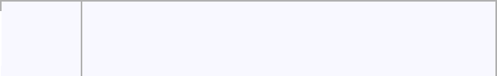

 **Input** **Result**



 **1** **Valid input.**



 **101** **Error: Number out of allowed range**



 **rec**  **Error: invalid literal for int()**

**def main():**



**Department of Computer Science and Engineering | Rajalakshmi Engineering College**

**.**

**min** **_** **range** **=** **1**

**max** **_** **range** **=** **100**

**try:**

**num** **=** **int(input())**

**if** **num** **<** **min** **_** **range** **or** **num** **>** **max** **_** **range:**

**print("Error:** **Number** **out** **of** **allowed** **range")**

**else:**

**print("Valid** **input.")**

**except** **ValueError:**

**print("Error:** **invalid** **literal** **for** **int()")**

**if** **__** **name** **__** **==** **"** **__** **main** **__** **":**

**OUTPUT:**

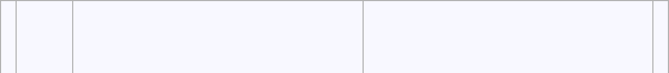

|  |  |  |  |
| --- | --- | --- | --- |
| **Inpu** | **Expected** | **Got** |  |
| **t** |  |
|  |  |  |



 **1**  **Valid** **input.**

 **100**  **Valid** **input.**

**101** **Error: Numberoutofallowed range**

**Passed** **all** **tests!**

 **Valid** **input.**

 **Valid** **input.**

**Error: Number out of allowed range**

**Correct**

**Marks for this submission: 1.00/1.00.**

**4.**

**Develop a Python program that safely performs division between two numbers provided by the user. Handle exceptions like division by zero and non-numeric inputs.**

**Input Format: Two lines of input, each containing a number.**

**Department of Computer Science and Engineering | Rajalakshmi Engineering College**

**.**



**Output Format: Print the result of the division or an error message if an exception occurs.**

**For example:**

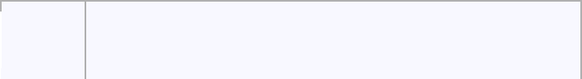

 **Input** **Result**

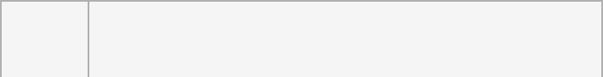

1. **5.0**

**2**



1. **Error: Cannot divide or modulo by zero.**

**0 **

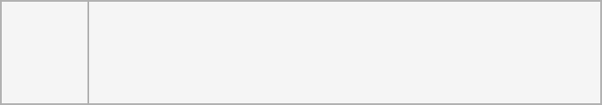

**ten** **Error: Non-numeric input provided.**

**5**

**def main():**

**try:**

**num1 = float(input())**

**num2 = float(input())**

**division_result = num1 / num2**

**modulo_result = num1 % num2**

**print(division_result)**

**except ValueError:**

**print("Error: Non-numeric input provided.")**

**except ZeroDivisionError:**

**print("Error: Cannot divide or modulo by zero.")**

**if __name__ == "__main__":**

**main()**



**Department of Computer Science and Engineering | Rajalakshmi Engineering College**

**.**

**OUTPUT:**

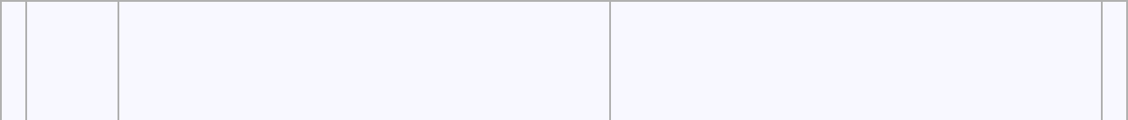

|  |  |  |  |
| --- | --- | --- | --- |
| **Inpu** | **Expected** | **Got** |  |
| **t** |  |
|  |  |  |



1. **5.0**

**2**



1. **Error: Cannot divide or modulo by**

**0zero.**



 **5.0**

**Error: Cannot divide or modulo by zero.**

**ten Error: Non-numeric input provided. Error: Non-numeric input provided. 5**

**Passed all tests!**



**Correct**



**5.**

**Problem Description:**

**Develop a Python program that safely calculates the square root of a number provided by the user.**

**Handle exceptions for negative inputs and non-numeric inputs.**

**Input Format:**

**User inputs a number.**

**Output Format:**

**Print the square root of the number or an error message if an exception occurs.**

**For example:**



|  |  |  |  |
| --- | --- | --- | --- |
| **Input** | **Result** |  |  |
| **16** | **The square root of 16.0** | **is 4.00** |  |
| **-4** | **Error: Cannot calculate** | **the square root of a negative number.** | |
| **rec** | **Error: could not convert string** | | **to float** |
| **try:** |  |  |  |

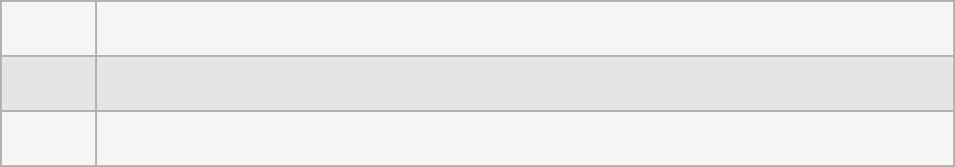

**a=float(input())**

**if(a<0):**

**print("Error: Cannot calculate the square root of a negative number.")**



**Department of Computer Science and Engineering | Rajalakshmi Engineering College**

**.**

**else:**

**print("The square root of",a,"is {:.2f}".format(a**0.5))**

**except:**

**print("Error: could not convert string to float")**

**OUTPUT:**

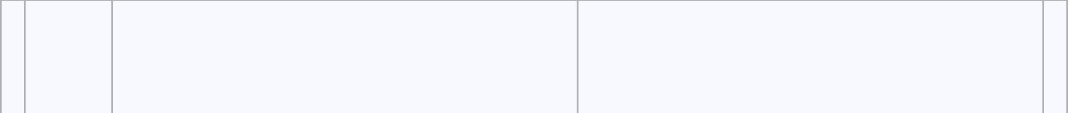

|  |  |  |  |
| --- | --- | --- | --- |
| **Inpu** | **Expected** | **Got** |  |
| **t** |  |
|  |  |  |
| **16** | **The square root of 16.0 is 4.00** | **The square root of 16.0 is 4.00** |  |
| **0** | **The square root of 0.0 is 0.00** | **The square root of 0.0 is 0.00** |  |
| **-4** | **Error: Cannot calculate the square** | **Error: Cannot calculate the square** |  |
|  | **root of a negative number.** | **root of a negative number.** |  |



**Passed all tests!**



**Correct**



|  |  |
| --- | --- |
| **Department of Computer Science and Engineering | Rajalakshmi Engineering College** | **.** |
|  |  |

